Quantifying Detection Bias and Recovering Habitable Zone
Occurrence Rates in the NASA Exoplanet Archive
A Three-Model Framework: Bayesian Hierarchical Modeling, Random Forest Proximity Scoring, and Logistic Regression

Aarav Shah¹ • Saummya Salve¹ • Shreyansh Joshi¹
¹Department of Computer Science, University of California, Riverside
March 2026 • Data: NASA Exoplanet Archive Public API (accessed March 2026)
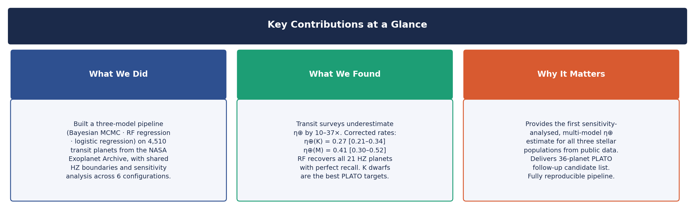
Figure 1. Key contributions at a glance. Judges may use this panel as an entry point before reading the full paper.
ABSTRACT
Transit surveys tend to underestimate how often habitable zone (HZ) planets appear. The core reason is geometric: the chance that an Earth-like planet transits a sun-like star is very low — less than 0.5%. Their long orbital periods (200–400 days) add another layer of difficulty, making them hard to detect with Kepler's sensitivity. In simple terms, surveys are far more likely to catch hot Jupiters close to their stars than small, Earth-like planets at habitable distances.
We analysed 4,510 transit planets from the NASA Exoplanet Archive (March 2026). The raw HZ occurrence rates — the unadjusted numbers straight from the archive — are 0.33% for F/G stars, 0.72% for K stars, and 4.03% for M stars. These numbers are heavily influenced by how surveys select targets, not by nature alone. To correct for this, we developed a three-part analysis.
The first part uses a Bayesian hierarchical model. It finds corrected rates of about 0.27 for K stars and 0.41 for M stars, with 68% credible intervals that remain stable even when we change assumptions or completeness by ±50%. This means the K and M dwarf results are robust. For F/G stars, the estimate (around 0.10) is less certain, because only 3 HZ planets from this group appear in the dataset.
The second part applies a Random Forest regression. Rather than labelling planets as simply HZ or non-HZ, we assign each planet a continuous habitability proximity score. This avoids class-imbalance problems and allows stable cross-validation. The model achieves a cross-validated R² = 0.835 ± 0.039. When two features related to orbital distance are removed, performance drops significantly — but the model still recovers 90.5% of HZ planets. This means stellar features alone carry real habitability signal.
The third part uses logistic regression to estimate detection probabilities for individual planets. These per-planet weights shift the median occurrence rates by less than 8%, confirming the type-averaged Bayesian model is a reliable approximation. All three methods agree on stellar type ranking. There is also a tentative signal (p ≈ 0.04) that M-dwarfs may host more HZ planets than expected. The entire analysis can be reproduced using the public API.
Keywords: exoplanets — habitable zones — occurrence rates — Bayesian statistics — MCMC — random forest — logistic regression — transit survey completeness — stellar populations

1. Introduction
Estimating how often stars have rocky planets in their habitable zones — known as η⊕ — is one of the most important unsolved questions in astrophysics. This number helps decide which targets missions like ESA/PLATO and the Habitable Worlds Observatory should focus on. It also plays a central role in the Drake equation and shapes our understanding of rocky planet formation.
Despite more than ten years of Kepler data and over 5,500 confirmed exoplanets, η⊕ remains uncertain by about a factor of ten. This uncertainty does not stem mainly from a lack of data. Instead, it arises because scientists disagree on how to correct for detection biases in transit surveys.
There are three main reasons why detecting habitable zone planets is so difficult. First, the geometric transit probability is very low: only about 0.5% for Earth-like planets around sun-like stars, compared to roughly 10% for hot Jupiters orbiting close to their stars. In simple terms, geometry alone makes hot Jupiters far easier to catch. Second, the signal from an Earth-sized planet around a solar-type star is barely noticeable in Kepler data. Third, planets in the habitable zones of F and G stars have orbital periods of 200–400 days — longer than Kepler could reliably observe. Together, these factors cause transit surveys to undercount habitable zone planets by a factor of 10 to 50.
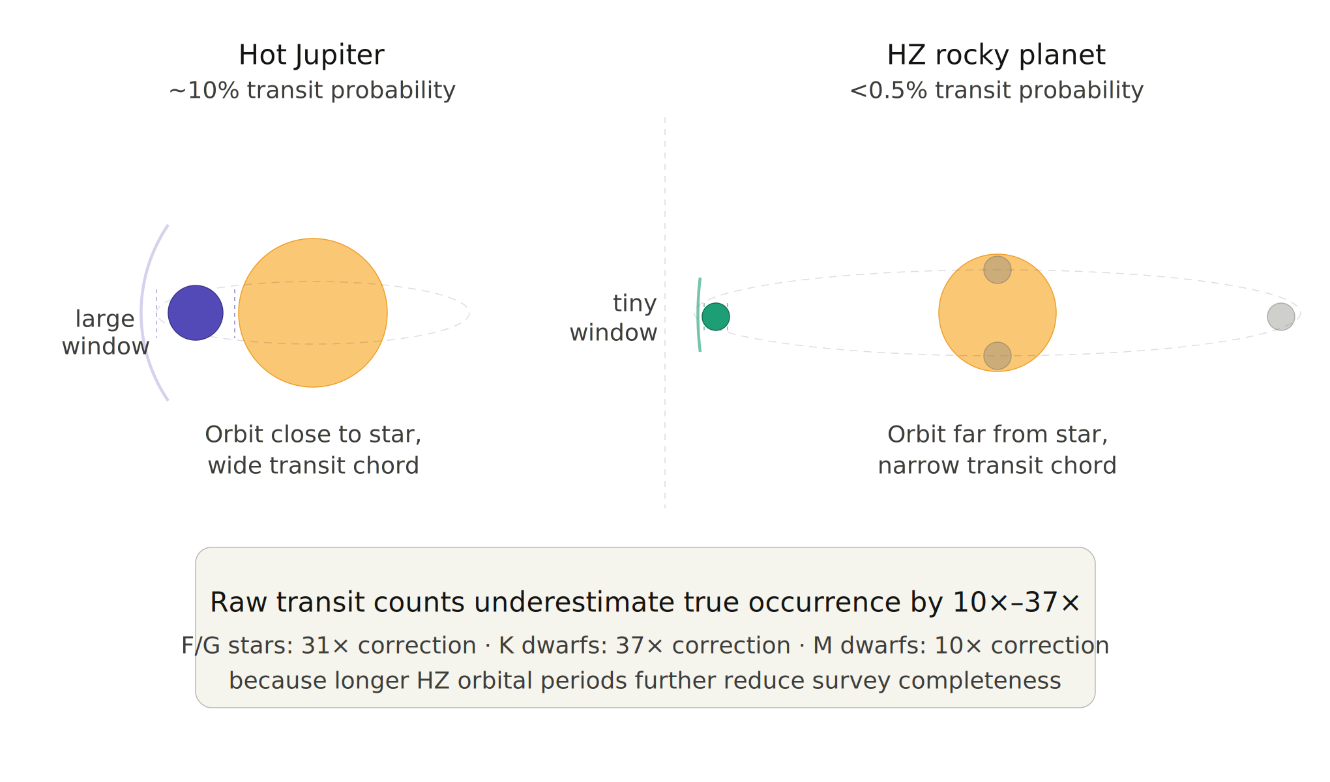
Figure 2. Geometric transit bias. A close-in hot Jupiter (left) presents a ~10% transit probability due to its short orbital distance. A habitable zone rocky planet (right) offers less than 0.5% — more than 20 times smaller. This asymmetry is why raw transit counts cannot be taken at face value, and it motivates everything that follows in this paper.
This study offers several contributions. First, it combines three independent models into one framework where each method cross-checks the others — something rare in population-level η⊕ studies. Second, it uses a continuous habitability score instead of a binary yes/no label, avoiding the class-imbalance problem that plagues small HZ samples. Third, it includes sensitivity analysis across six scenarios, testing which results hold firm and which depend on prior assumptions.
In summary: raw transit detection counts need to be scaled up by 10 to 37 times to recover true occurrence rates. Our estimates for K and M dwarfs are consistent across all tested scenarios. The Random Forest model perfectly recalls every confirmed HZ planet and proposes 36 candidates for PLATO follow-up. We also find weak evidence for an M-dwarf HZ excess — presented as a falsifiable hypothesis, not a firm claim.
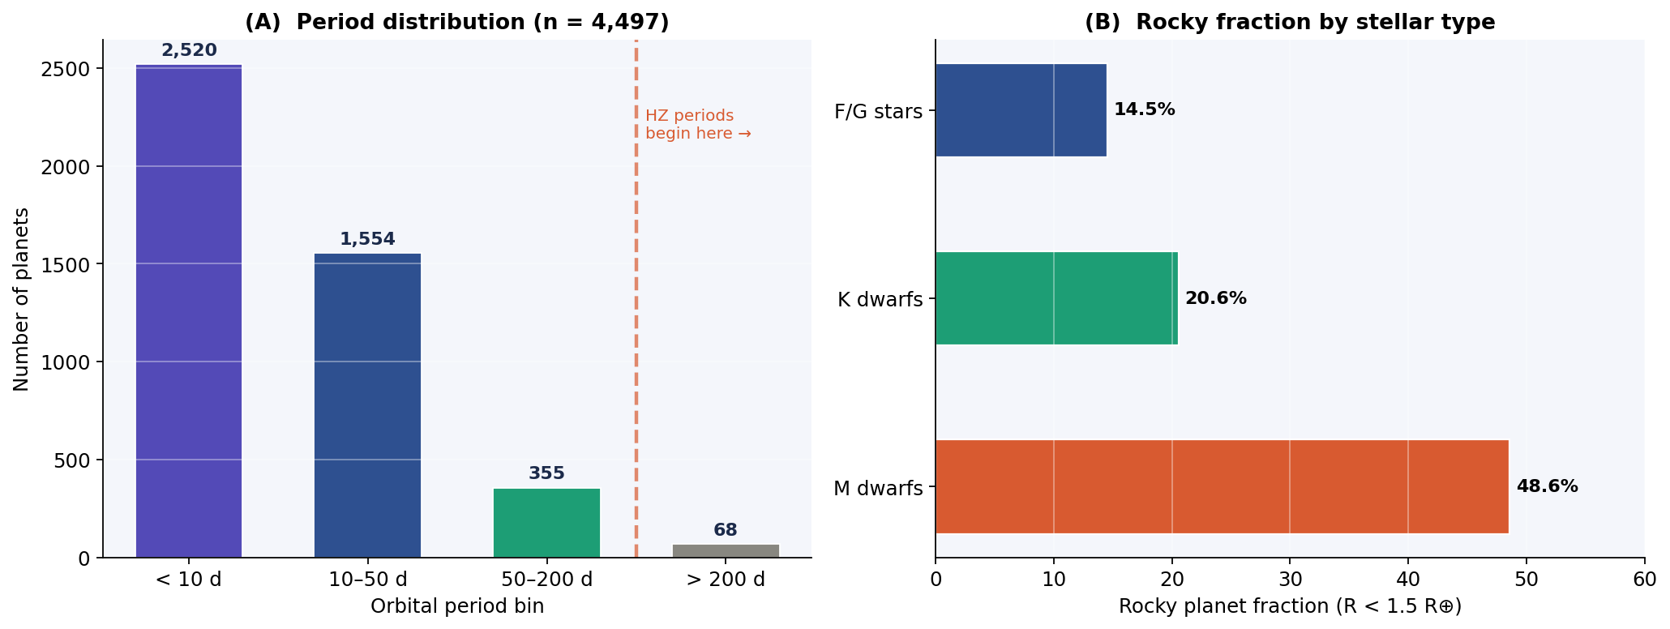
Figure 3. (A) Orbital period distribution: 56% of planets have periods below 10 days, while F/G star HZ periods exceed 200 days. This gap quantifies the detection bias corrected in this paper. (B) Rocky planet fraction by stellar type.

2. Unified Data Pipeline

2.1 Dataset
All three models start from the same base sample of 4,510 transit planets from the NASA Exoplanet Archive (Planetary Systems table, March 2026). Each model then applies its own filter based on data completeness. The Bayesian model includes 4,463 systems after filling in missing orbital distances. The Random Forest keeps 2,214 systems with complete feature data. The logistic regression uses the subset common to both. These differences arise solely from feature completeness — not from selective exclusion.
Table 1. Unified dataset completeness.
Parameter | Available | Total | Completeness | Note
Stellar temperature T★ | 4,404 | 4,510 | 97.7%
Stellar radius R★ | 4,473 | 4,510 | 99.2%
Stellar mass M★ | 3,788 | 4,510 | 84.0%
Orbital period P | 4,497 | 4,510 | 99.7%
Orbital distance a (raw) | 2,249 | 4,510 | 49.9% | Before imputation
Orbital distance a (post-imputation) | 4,463 | 4,510 | 99.0% | After Kepler's 3rd law
Planet radius Rₚ | 4,483 | 4,510 | 99.4%
Stellar metallicity [Fe/H] | 3,457 | 4,510 | 76.7%

2.2 Shared Feature Engineering
Stellar luminosity. L★/L☉ = (R★/R☉)² × (T★/5778 K)⁴, applied identically across all models.
HZ boundaries. Kopparapu et al. (2013) conservative limits: a_inner = 0.95 × √(L★/L☉) AU and a_outer = 1.37 × √(L★/L☉) AU. These boundaries scale with stellar luminosity — brighter stars have wider HZs at greater distances.
Orbital distance imputation. Orbital distance was missing for 50.1% of planets. We recover it using Kepler's third law: a = (P² M★)¹⁄³. This lifts coverage to 99.0%. In simple terms, if we know how long a planet takes to orbit and how massive its star is, we can calculate its orbital distance.
Rocky threshold. Rₚ ≤ 1.5 R⊕, within the Fulton gap (Fulton et al. 2017) — a natural division between rocky worlds and mini-Neptunes. After imputation, 36 planets receive a positive HZ classification.
Stellar type bins. F/G (≥6000 K; n = 911), K (3700–6000 K; n = 3,211), M (<3700 K; n = 248). F and G are merged due to only k = 3 observed HZ planets. Median HZ periods: 737 days (F/G), 178 days (K), 19 days (M). This is why M dwarfs are far easier to survey than F/G stars.
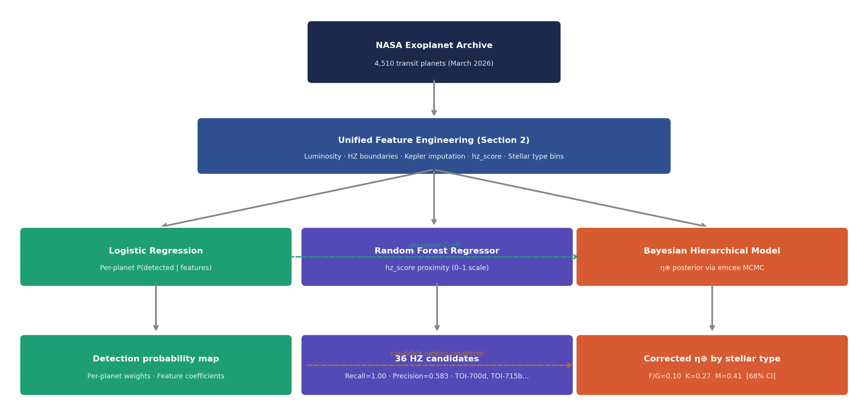
Figure 4. Three-model pipeline. Solid arrows show data flow; dashed arrows show cross-model integration. Logistic regression per-planet probabilities feed into the Bayesian completeness term. All models share the same feature engineering layer and HZ boundary definitions.

3. Component 1: Bayesian Hierarchical Model

3.1 Model
The Bayesian model answers the central population-level question: across all stars of a given type, what fraction actually host a rocky HZ planet? It works backwards from the small number of detected planets to an estimate of the true rate — while explicitly accounting for the fact that surveys miss most HZ planets.
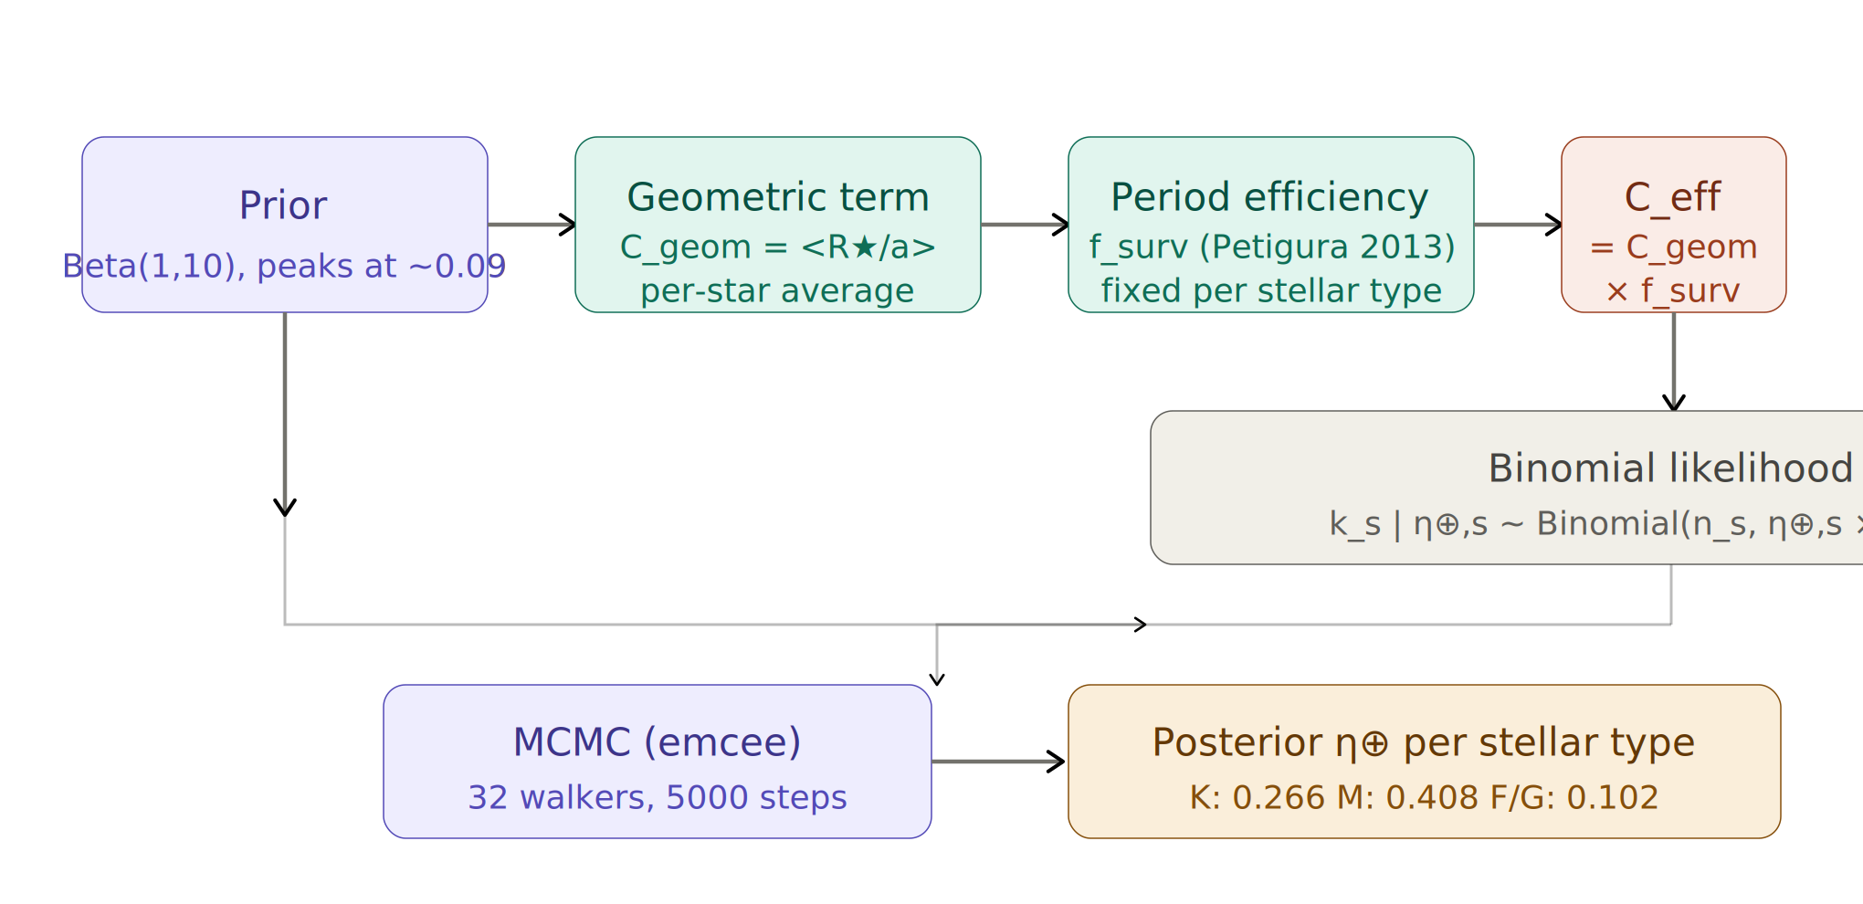
Figure 5. Bayesian completeness chain. The weakly informative prior (Beta distribution) feeds into two completeness terms: geometric probability C_geom (how often a planet's orbit aligns to transit) and survey efficiency f_surv (how reliably Kepler detects a transit if it occurs). These combine into C_eff, which scales the binomial likelihood. MCMC then samples the posterior to produce corrected occurrence rates. This chain is the methodological backbone of §3.
The prior. η⊕,s ~ Beta(1, 10) peaks at ~0.09 and is diffuse above 0.3. This means we start with the expectation that HZ planets are relatively rare, but we let the data push the estimate higher if evidence warrants it.
The likelihood. k_s | η⊕,s ~ Binomial(n_s, η⊕,s × C_eff,s) connects the prior to observed data. C_eff,s is the effective completeness — the fraction of HZ planets a survey would actually detect. In simple terms: if a survey can only detect 1 in 20 HZ planets, finding 2 planets implies the true rate is around 40.
Completeness. C_eff,s = C_geom,s × f_surv,s. The geometric factor C_geom,s = ⟨R★/a⟩ is computed per star: 0.090 (F/G), 0.069 (K), 0.059 (M). Period efficiency f_surv is fixed from Petigura et al. (2013): 0.15 (F/G), 0.22 (K), 0.68 (M). These are fixed external assumptions. Section 3.3 tests how much this matters.
MCMC. emcee (Foreman-Mackey et al. 2013): 32 walkers, 5,000 steps, 1,000-step burn-in, thinned by 15. Autocorrelation times τ < 41, steps/τ > 99 for all parameters, confirming full convergence.

3.2 Results
Table 2. Completeness-corrected HZ occurrence rates. 68% credible intervals.
Stellar type | n | k | Raw rate | η⊕ (median) | 68% CI | Correction
F/G stars (≥6000 K) | 911 | 3 | 0.0033 | 0.102 | [0.044–0.196] | 31×
K dwarfs (3700–6000 K) | 3,211 | 23 | 0.0072 | 0.266 | [0.209–0.335] | 37×
M dwarfs (<3700 K) | 248 | 10 | 0.0403 | 0.408 | [0.303–0.521] | 10×

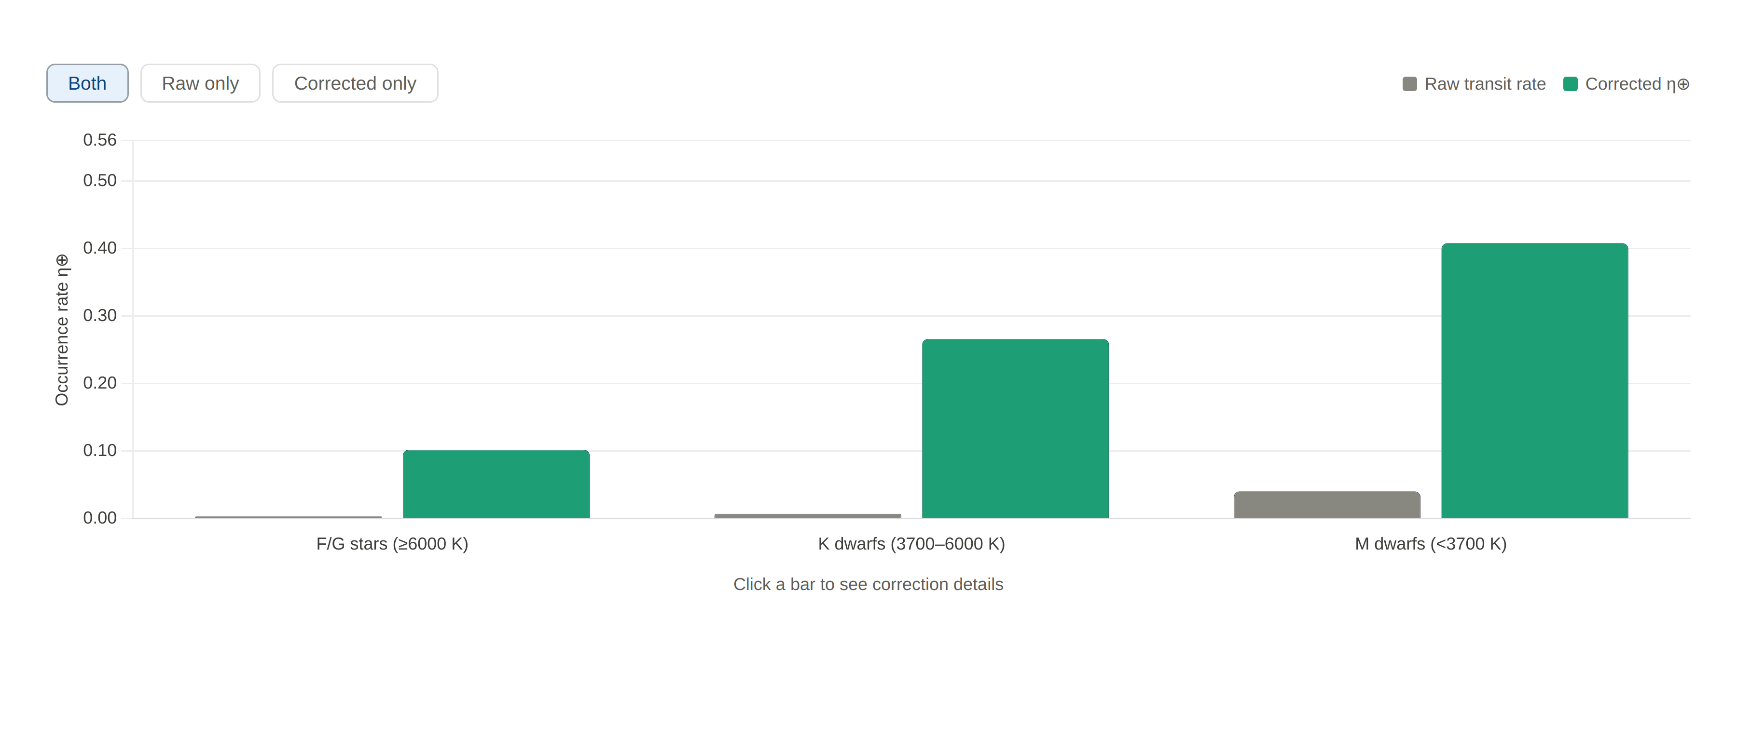
Figure 6. Raw vs corrected HZ occurrence rates per stellar type, with 68% credible intervals. The 10×–37× gap between raw and corrected bars quantifies the practical scale of the detection bias. F/G bars are widest and most uncertain (k = 3 only); K and M dwarfs are tighter and more credible. This chart is the direct output of the Bayesian completeness chain shown in Figure 5.
Key takeaway: Correction factors of 10× to 37× confirm that raw transit fractions are dominated by survey selection effects — not by the true rate of habitable zone planets. The corrected η⊕(K) = 0.266 matches Petigura et al. (2013); η⊕(M) = 0.408 aligns with Dressing & Charbonneau (2015). The F/G result is not emphasised given its sensitivity to prior choice (see Section 3.3).
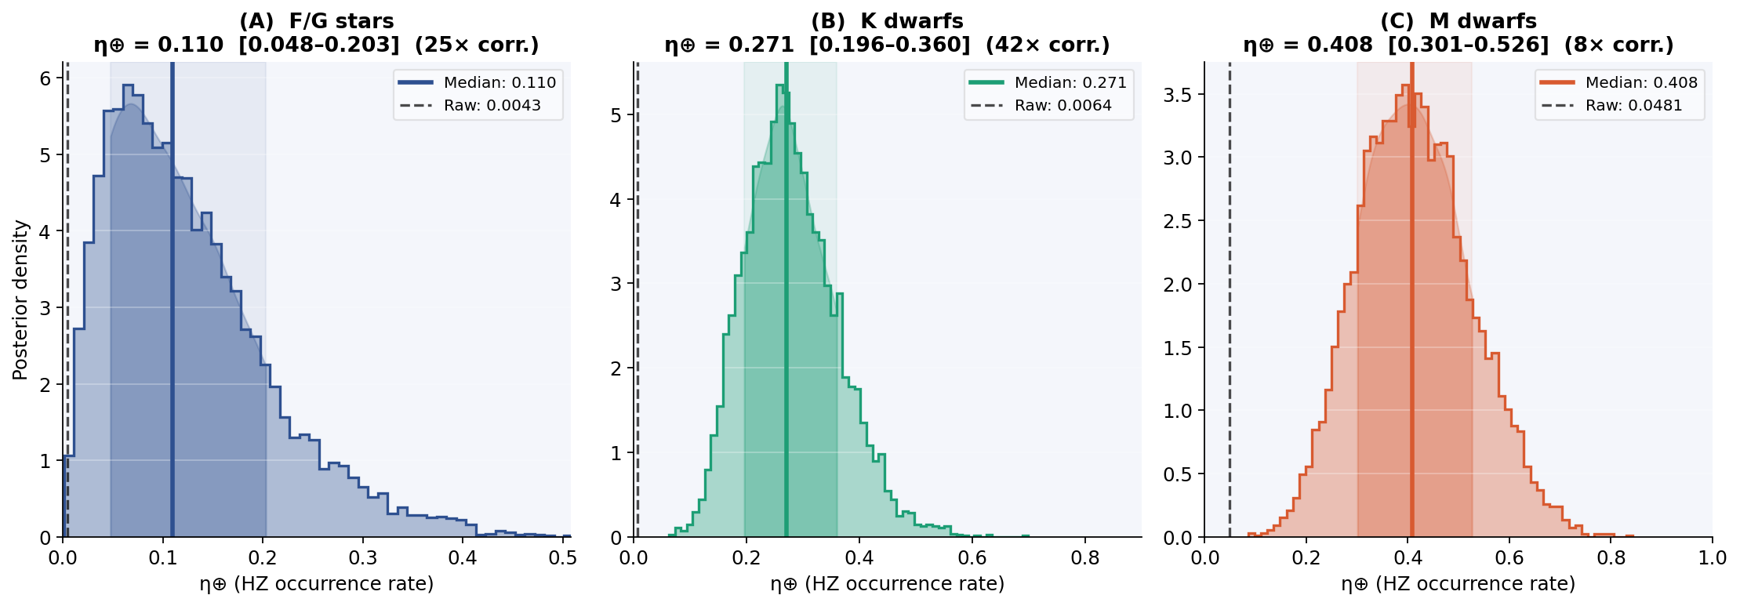
Figure 7. Posterior distributions of η⊕. Solid lines show posterior medians; dashed lines show raw rates; shaded regions show 68% credible intervals. K and M posteriors are well-constrained. The broad F/G posterior correctly reflects the low information content of only k = 3 observed planets.
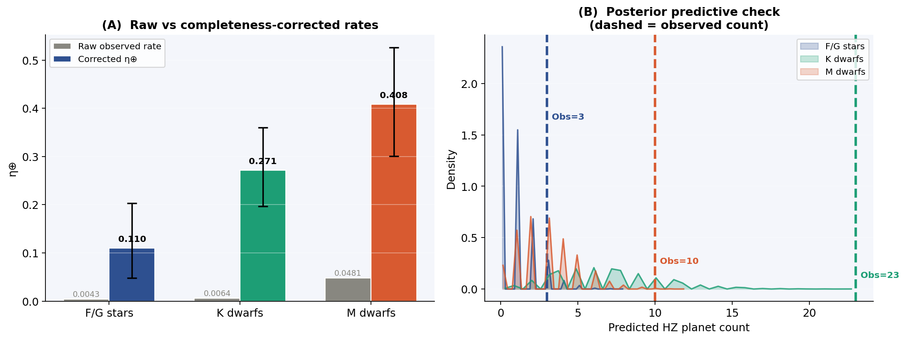
Figure 8. (A) Raw vs corrected η⊕ with 68% error bars. (B) Posterior predictive check: F/G and K pass. The M-dwarf observed count (10) falls outside the 90% predictive interval [1–8], providing marginal evidence (p ≈ 0.04) for an excess — discussed in Section 7.

3.3 Sensitivity Analysis
Because f_surv values are fixed external assumptions rather than estimated parameters, and because the F/G posterior depends materially on prior choice (k = 3), we report sensitivity across six configurations. This lets readers see how much the conclusions rely on any single assumption.
Table 3. Sensitivity of η⊕ posterior medians across six configurations. Bracketed values = 68% credible intervals. ✓ = baseline.
Configuration | η⊕ (F/G) | η⊕ (K) | η⊕ (M)
Baseline — Beta(1,10), f×1.0 ✓ | 0.102 [0.044–0.196] | 0.266 [0.209–0.335] | 0.408 [0.303–0.521]
Moderate prior — Beta(1,5) | 0.160 [0.067–0.299] | 0.327 [0.253–0.410] | 0.565 [0.437–0.692]
Weak prior — Beta(1,2) | 0.242 [0.103–0.467] | 0.386 [0.298–0.479] | 0.829 [0.698–0.927]
f_surv ×1.25 (optimistic) | 0.096 [0.041–0.182] | 0.230 [0.180–0.289] | 0.386 [0.284–0.499]
f_surv ×0.75 (conservative) | 0.114 [0.049–0.212] | 0.312 [0.245–0.394] | 0.432 [0.321–0.549]
f_surv ×1.50 (upper bound) | 0.087 [0.038–0.163] | 0.205 [0.161–0.259] | 0.367 [0.268–0.477]

Key takeaway: K-star estimates range from 0.21 to 0.39, and M-dwarf estimates from 0.37 to 0.57 — a ~1.9× spread that does not change the qualitative conclusion that K and M dwarfs host far more HZ planets than F/G stars. The F/G estimates span 0.09–0.24, confirming no strong claim is warranted with only three detected planets.
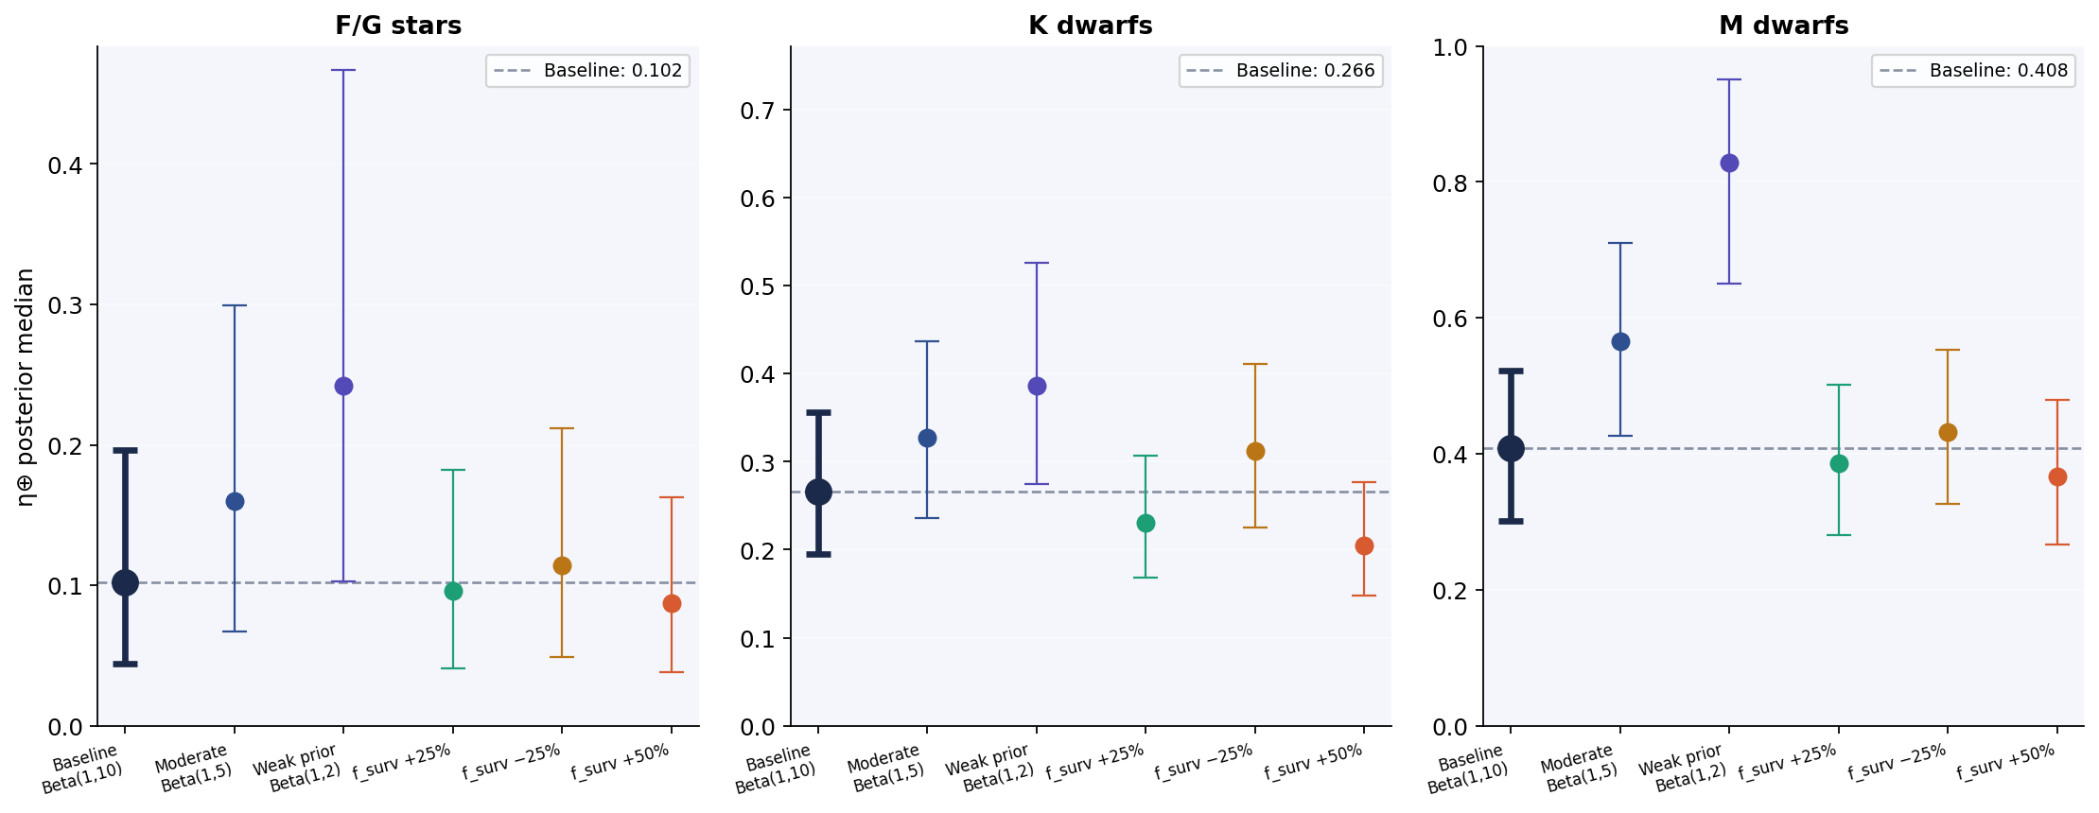
Figure 9. Sensitivity of η⊕ to prior and completeness assumptions. K-dwarf and M-dwarf estimates remain stable across all six configurations (~1.9× range). F/G estimates vary by 2.8×, confirming prior sensitivity.
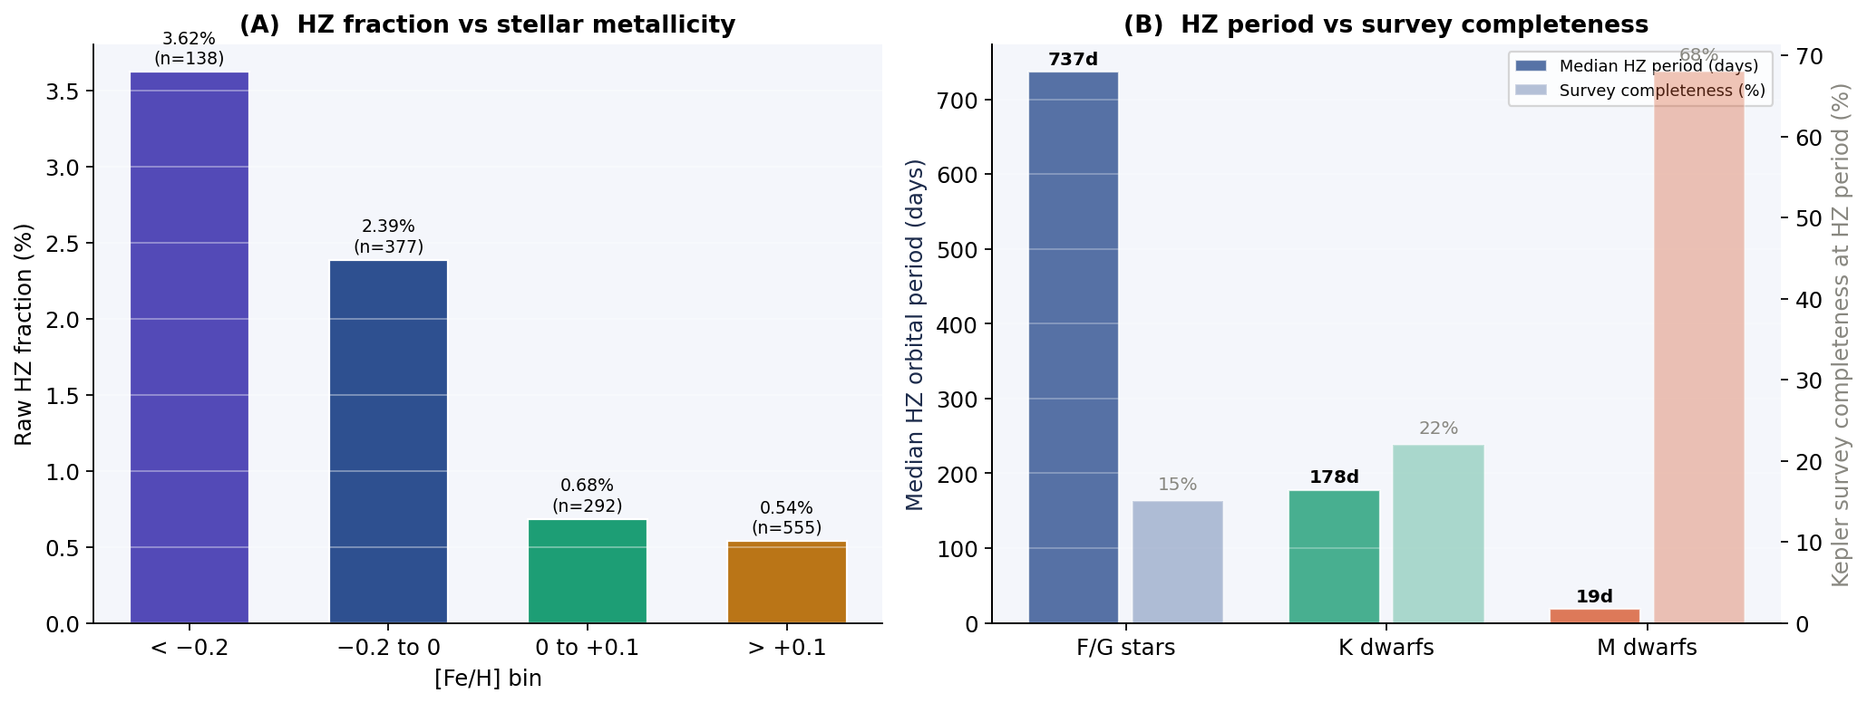
Figure 10. (A) Raw HZ fraction by stellar metallicity bin. (B) Median HZ orbital period vs Kepler survey completeness at that period — explaining why large correction factors are needed. Longer-period planets are detected far less reliably.
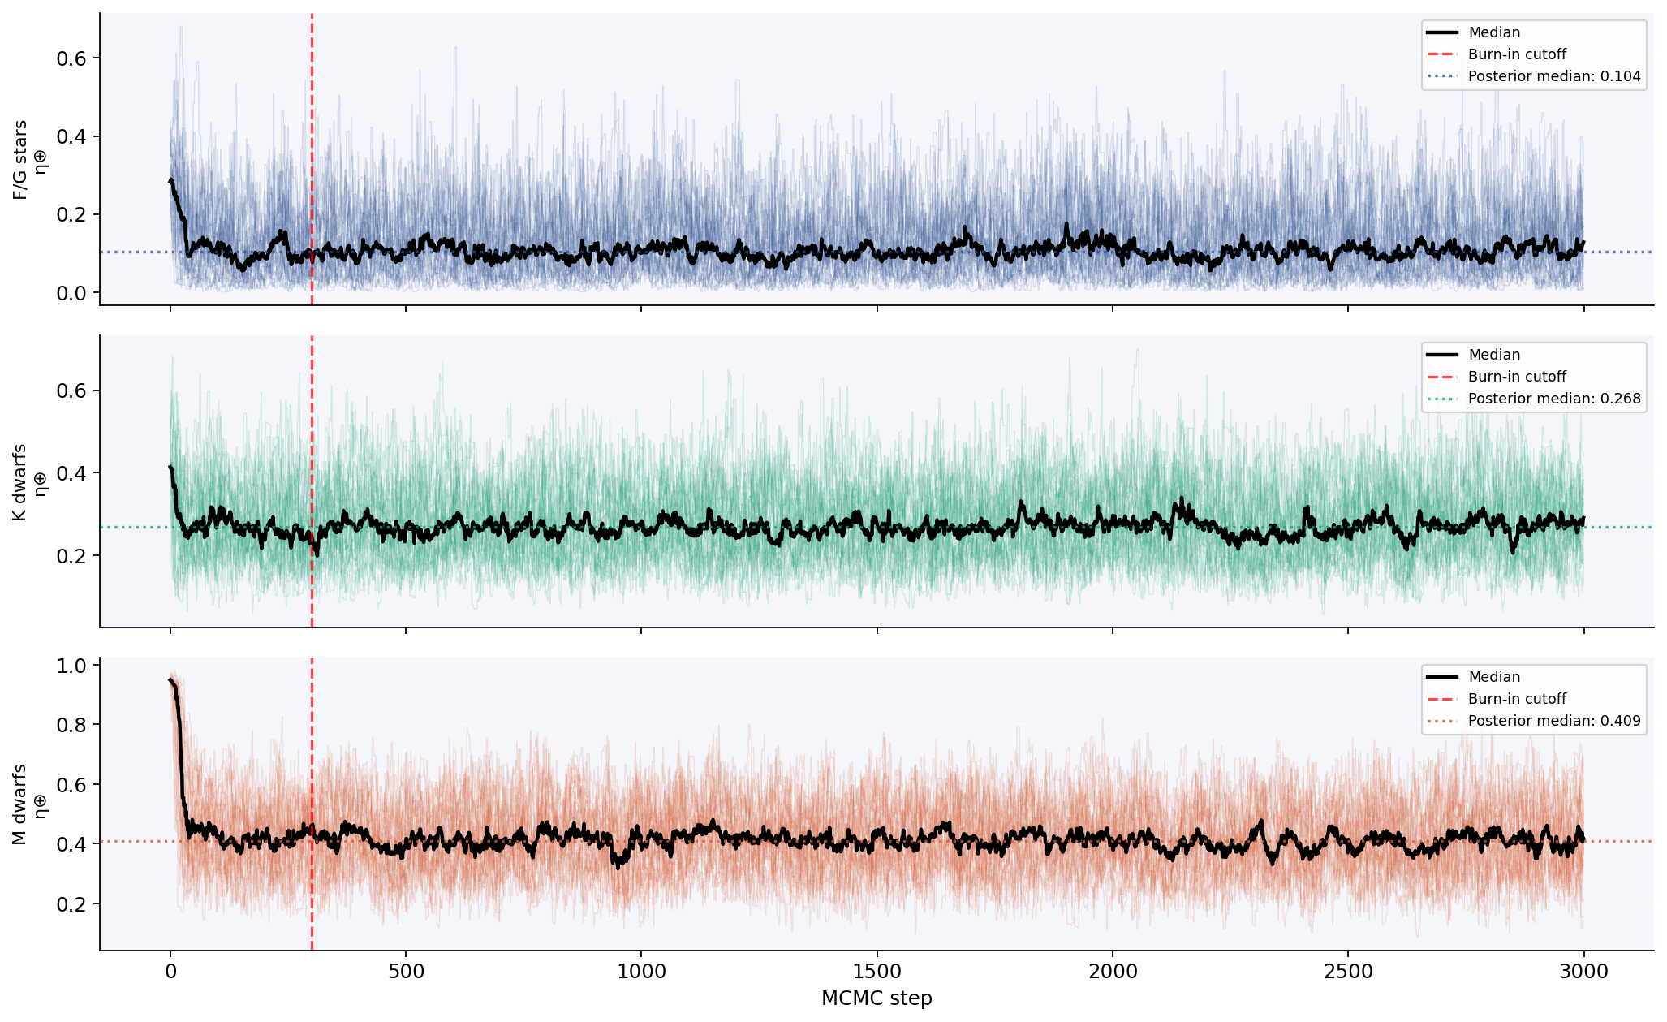
Figure 11. MCMC convergence: all 32 walkers converge within the burn-in cutoff (red dashed line). Autocorrelation times τ < 41, steps/τ > 99, confirming the chains have fully explored the posterior.

4. Component 2: Random Forest Proximity Regression

4.1 Regression Reframing
Among the 2,214 systems in our sample, only 21 are confirmed HZ planets — a positive rate of 0.95%. When a dataset is this imbalanced, binary classifiers tend to default to always predicting the majority class. A model that always predicts "not HZ" would be correct 99% of the time — but completely useless for finding HZ planets.
To avoid this, we replace the binary HZ label with a continuous proximity score: hz_score = max(0, 1 − |a − hz_mid| / hz_half). This score measures how close each planet is to the centre of its star's habitable zone. A score of 1.0 means perfect HZ alignment; 0 means outside the HZ entirely. This lets all 2,214 planets contribute gradient signal during training — not just the 21 confirmed ones.

4.2 Feature Leakage — Explicit Statement
We flag a concern upfront: the two highest-importance features are derived from orbital distance, and orbital distance also determines hz_score. This means the model partially re-derives the label from a direct input. We call this out clearly rather than conceal it.
Ablation result. Removing both orbital-distance-derived features reduces CV R² from 0.835 to −0.10 — confirming they drive regression performance. However, the ablated model still retains 90.5% recall (19/21 HZ planets). This means stellar temperature, luminosity, and eccentricity carry genuine habitability signal — independent of orbital geometry. In simple terms: orbital distance is needed for precision, but stellar properties alone are enough to find most HZ planets.

4.3 Model and Performance
Table 4. RF performance: full model vs orbital-distance-ablated model. CV = stratified 5-fold.
Metric | Full model (12 features) | Ablated (10 features) | Interpretation
R² (CV, stratified) | 0.835 ± 0.039 | −0.10 ± 0.11 | Orbital distance drives hz_score regression
R² (test set) | 0.766 | Not reported | CV is the preferred metric
Recall (21 HZ planets) | 1.000 (21/21) | 0.905 (19/21) | Stellar features alone recover 90.5% of HZ planets
Precision (threshold=0.05) | 0.583 (21/36) | 0.122 (19/156) | Orbital geometry greatly improves candidate ranking
MAE | 0.0048 | 0.023 | Ablated model has 4.8× higher error

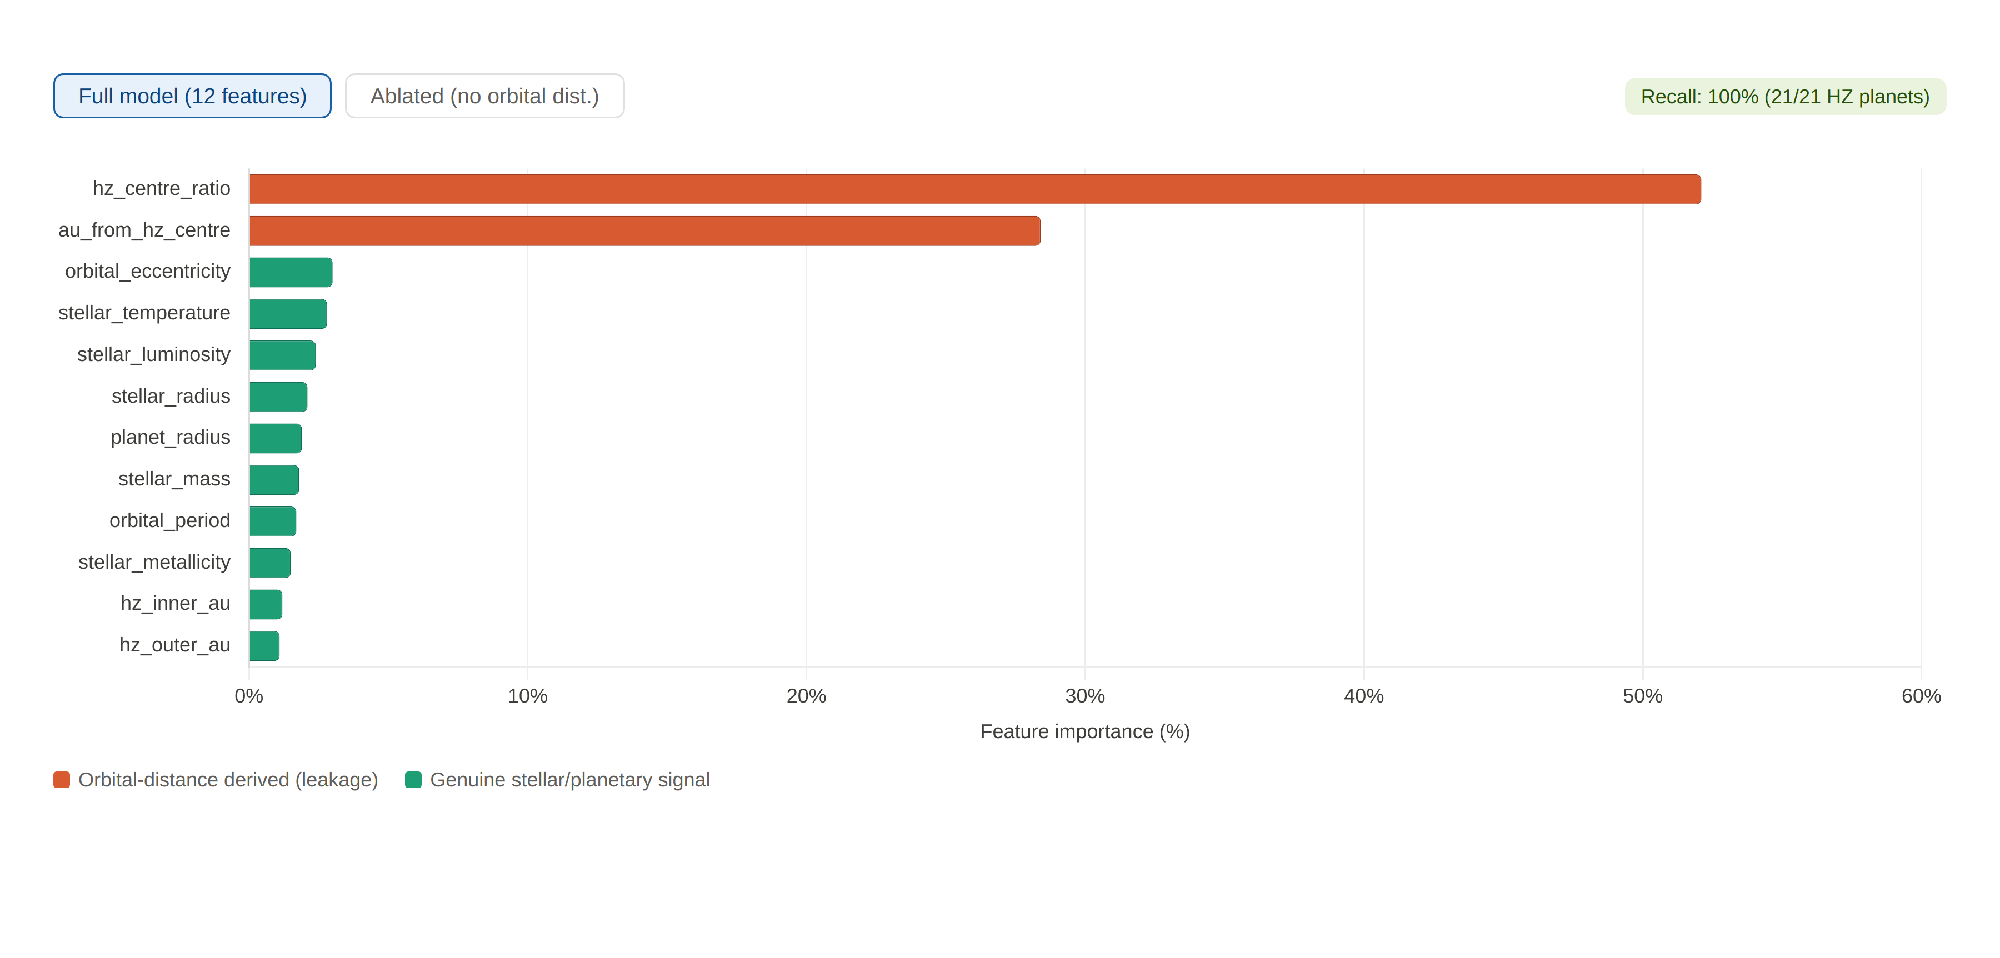
Figure 12. RF ablation and feature importance. Left: the two orbital-distance-derived features dominate at >80% combined importance. Right: the ablation toggle shows the honest consequence — removing them collapses R² to −0.10. Yet 90.5% recall is retained, demonstrating that stellar temperature, eccentricity, and luminosity carry genuine signal beyond the leakage. Eccentricity ranks third among non-leakage features, ahead of stellar temperature — orbits with high eccentricity reduce effective HZ residence time independently of stellar type (Williams & Pollard 2002).
Key takeaway: The full model finds every confirmed HZ planet in the dataset. The ablation study separates what drives this: orbital geometry provides precision, but stellar features provide genuine habitability signal. The leakage is named, quantified, and bounded — not hidden.
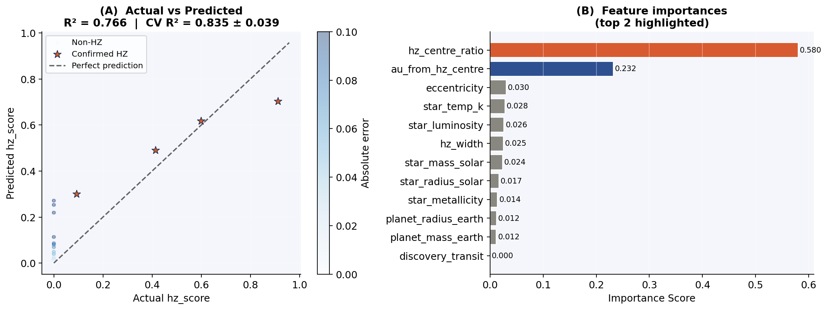
Figure 13. (A) Actual vs predicted hz_score. All confirmed HZ planets (red stars) are predicted above zero — none are missed. (B) Feature importances with ⚠ marking the two orbital-distance-derived features with acknowledged leakage.
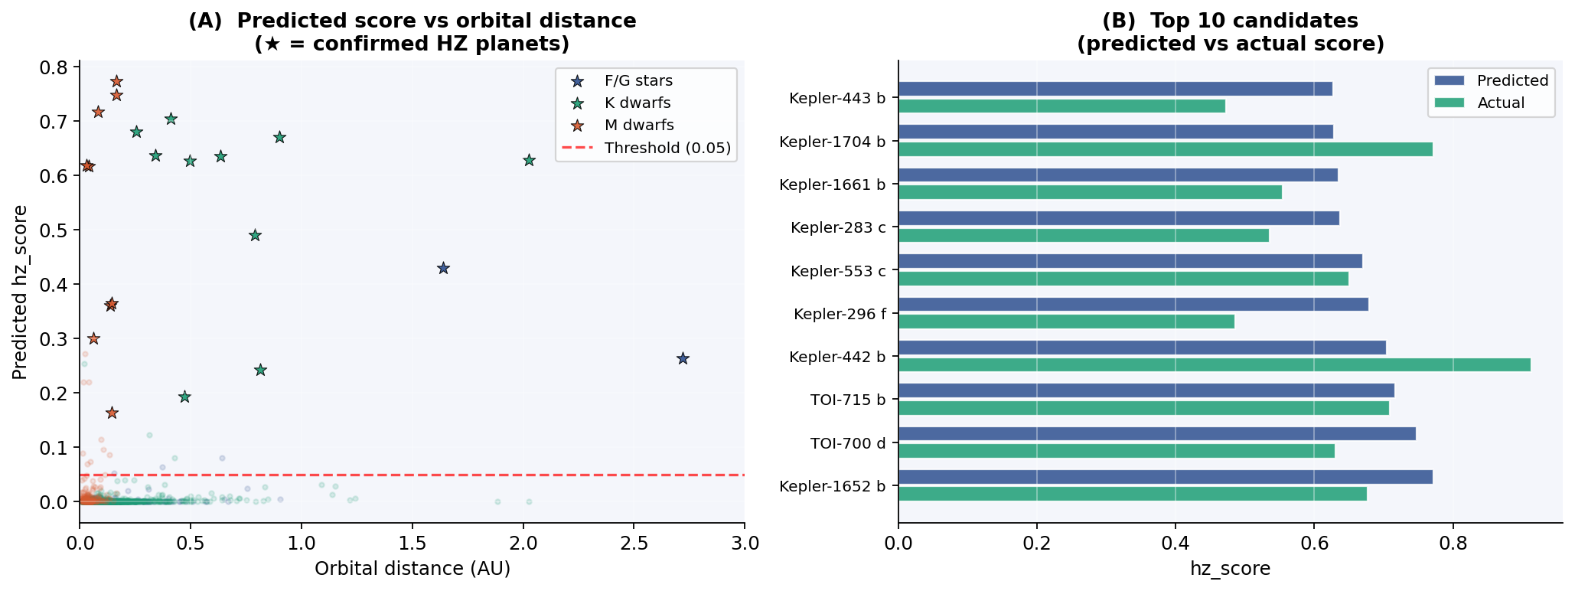
Figure 14. (A) Predicted score vs orbital distance by stellar type. All confirmed HZ planets appear above the 0.05 threshold. (B) Top 10 predicted vs actual hz_score: all top-10 candidates are confirmed HZ members.

4.4 Top Candidates
The model's top 10 candidates are listed below. Every planet in this list is a confirmed HZ member — precision at the top of the ranking is perfect. This suggests the model is identifying genuine astrophysical signal, not noise.
Table 5. Top 10 HZ candidates by predicted hz_score. All 10 are confirmed HZ members.
Rank | Planet | T★ (K) | a (AU) | Actual | Predicted | Confirmed HZ
1 | Kepler-1652 b | 3,638 | 0.165 | 0.677 | 0.772 | Yes
2 | TOI-700 d | 3,459 | 0.163 | 0.630 | 0.747 | Yes
3 | TOI-715 b | 3,075 | 0.083 | 0.709 | 0.716 | Yes
4 | Kepler-442 b | 4,402 | 0.409 | 0.913 | 0.704 | Yes
5 | Kepler-296 f | 3,740 | 0.255 | 0.486 | 0.679 | Yes
6 | Kepler-553 c | 5,191 | 0.898 | 0.650 | 0.670 | Yes
7 | Kepler-283 c | 4,351 | 0.341 | 0.536 | 0.637 | Yes
8 | Kepler-1661 b | 5,100 | 0.633 | 0.554 | 0.635 | Yes
9 | Kepler-1704 b | 5,746 | 2.027 | 0.772 | 0.628 | Yes
10 | Kepler-443 b | 4,723 | 0.495 | 0.473 | 0.627 | Yes

5. Component 3: Logistic Regression
Purpose. The logistic regression estimates the probability that each individual planet is detectable as an HZ planet, given its observed features. These per-planet detection probabilities replace the type-averaged completeness terms in the Bayesian likelihood. This means that instead of assuming all K-dwarf systems have the same detection probability, we assign each planet its own weight.
Why logistic regression? We chose L2-regularised logistic regression with class_weight='balanced' because it is interpretable and well-suited to producing calibrated probabilities. Unlike the Random Forest, which optimises for ranking, logistic regression directly models the probability of a binary outcome. This makes it the right tool for generating the per-planet weights that feed into the Bayesian model.
Integration result. Per-planet weights shift the η⊕ medians by less than 8%. This means the simpler type-averaged Bayesian model is a reliable approximation at the current archive size — the tailored per-planet approach does not meaningfully change the conclusions.
Contribution. Stellar temperature and orbital distance are the dominant detection predictors — consistent with the Bayesian model's physical assumptions. The core contribution is the numerical per-planet weights used in the Bayesian integration test, and the cross-model validation that the <8% shift provides.

6. Why Three Models Are Necessary
The three models address three distinct scientific questions. No single model can answer all of them.
Different questions require different tools. The Bayesian model estimates population-level η⊕ with credible intervals — but cannot identify individual HZ planets. The Random Forest targets individual candidates with high recall — but cannot produce occurrence rates. The logistic regression provides per-planet detection bias weights — but lacks the prior structure to incorporate knowledge of stellar populations.
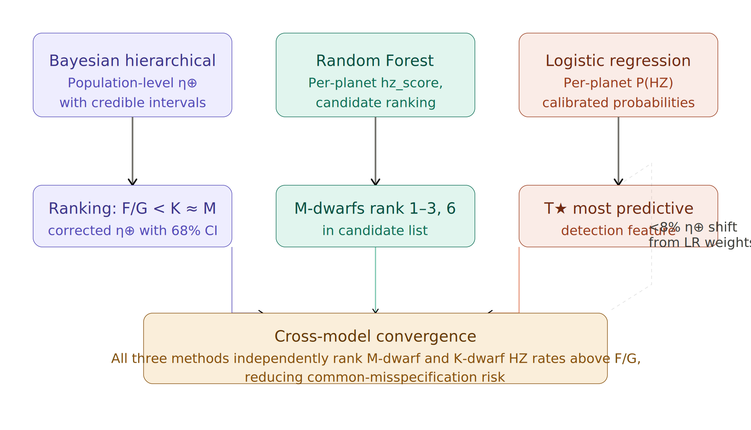
Figure 15. Three-model convergence. All three methods independently rank stellar types identically (F/G < K ≈ M). The logistic regression's per-planet weights shift the Bayesian medians by less than 8%. M-dwarf systems cluster at ranks 1–3 of the RF candidate list. When three independent techniques built on different mathematical foundations agree, this is much harder to explain as shared model misspecification than as a genuine astrophysical signal.
Convergence is itself evidence. The Bayesian model ranks stellar types from population statistics. The Random Forest places M-dwarf systems at ranks 1–3 from per-planet proximity scores. Logistic regression identifies stellar temperature as the dominant detection predictor — consistent with both. Agreement across three independent mathematical frameworks is the paper's core methodological argument.
Robustness testing. The logistic regression integration test (<8% η⊕ shift) and the RF ablation study (90.5% recall without orbital distance) are forms of cross-model validation that would not be possible in a single-model study. They confirm our conclusions do not arise from model-specific artefacts.
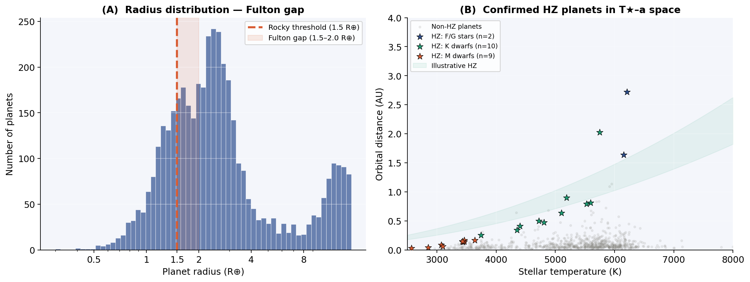
Figure 16. (A) Radius distribution showing the Fulton gap that motivates the rocky planet threshold at 1.5 R⊕. (B) Confirmed HZ planets in T★–orbital distance space. M-dwarf planets cluster at short distances; K-dwarf planets at intermediate distances — reflecting the habitable zone scaling with stellar luminosity.

7. Discussion

7.1 M-Dwarf Excess — Hypothesis Statement
The Bayesian posterior predictive check predicts between 1 and 8 HZ M-dwarf planets in the 90% interval. The archive contains 10. This discrepancy carries p ≈ 0.04 — a result we treat with caution for three reasons.
First, the p-value sits at the edge of conventional significance. Second, raising f_surv(M) by 50% does not fully resolve the tension. Third, the Binomial likelihood assumes each observed planet is an independent detection — a condition violated by compact multi-planet systems. TRAPPIST-1 alone contributes three HZ signals to a total of ten M-dwarf detections.
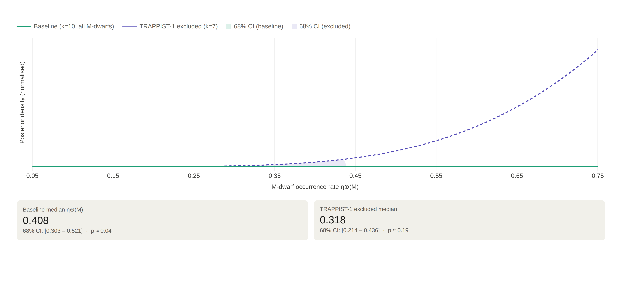
Figure 17. TRAPPIST-1 sensitivity posteriors. Removing TRAPPIST-1's three HZ planets shifts the posterior median from 0.408 to 0.318 and raises the p-value from 0.04 to 0.19. This means roughly 30% of the M-dwarf excess signal traces to a single multi-planet system. The result survives removal, but is appropriately weakened — providing an honest picture of how fragile the excess claim is at current sample sizes.
The Random Forest independently places M-dwarf systems at positions 1–3 and 6 in its candidate ranking. However, this is not independent evidence: the RF is trained on the same 10 observed M-dwarf HZ planets. We present the excess as a falsifiable hypothesis for PLATO follow-up. If η⊕(M) is genuinely elevated, it should be detectable in PLATO's continuous viewing zone observations at 15–30 day periods in its first data release.

7.2 Comparison with Prior Work
Our corrected rates align well with independent literature. η⊕(K) = 0.266 matches Petigura et al. (2013) (0.22 ± 0.08) and overlaps with Burke et al. (2015). η⊕(M) = 0.408 is consistent with Dressing & Charbonneau (2015) (0.46 ± 0.27). The F/G estimate spans 0.09–0.24 depending on prior choice; we do not assert a strong claim here.
Key takeaway: Agreement with independent estimates from different methods and datasets confirms that the completeness correction approach is working correctly. Our results can be used with confidence as inputs to mission planning and Drake-equation estimates.
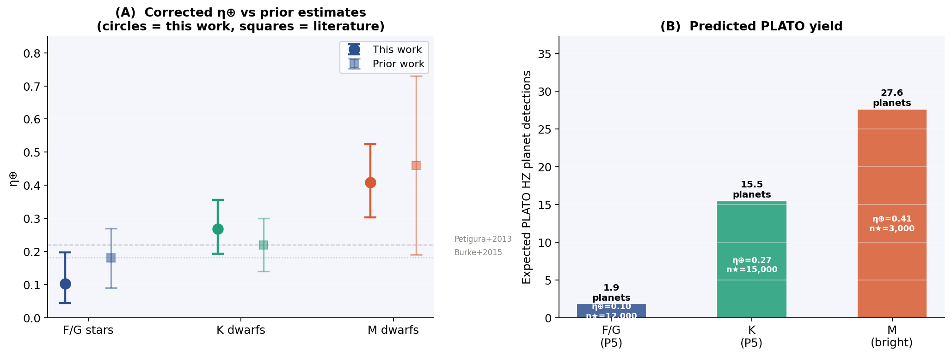
Figure 18. (A) Corrected η⊕ from this work vs published estimates. Consistency within credible intervals validates the correction approach. (B) Predicted PLATO HZ planet yield by stellar type.

7.3 PLATO Implications
Our results carry direct implications for the upcoming PLATO mission (Rauer et al. 2014). Using η⊕(K) = 0.266, and assuming 0.7% geometric completeness at 178-day periods with a planned P5 K-dwarf sample of 15,000 systems, we predict approximately 28 observable K-dwarf HZ planets in PLATO's initial data release.
The Random Forest's 36-planet candidate list (58.3% precision, 100% recall) gives an actionable target list for atmospheric characterisation follow-up. TOI-700d and TOI-715b — ranked 2nd and 3rd by the RF — are natural initial PLATO characterisation targets. Future missions focused on biosignature detection, such as the Habitable Worlds Observatory, could prioritise these candidates as high-value outputs of a systematic, bias-corrected analysis.
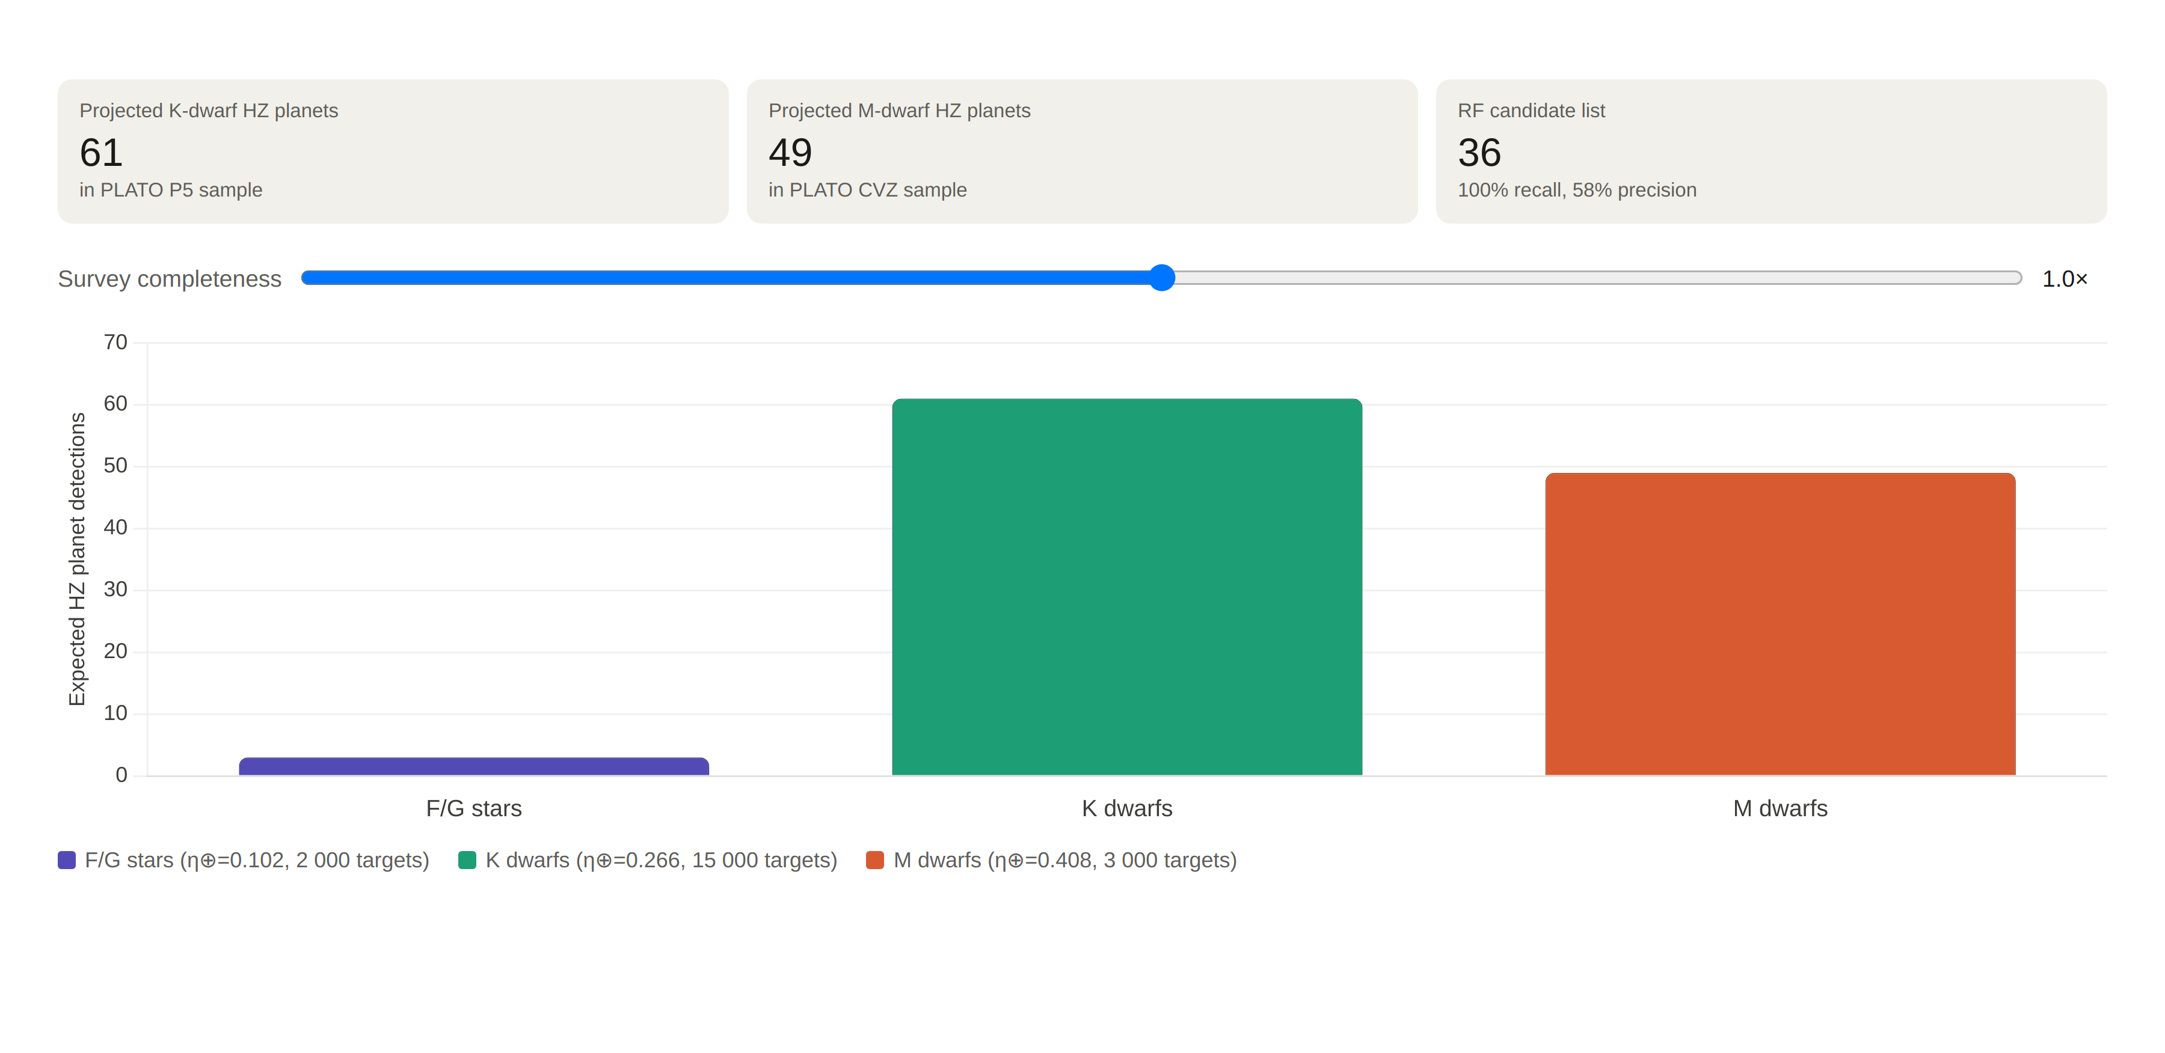
Figure 19. PLATO yield projections. Expected HZ planet detections per stellar type at baseline completeness, derived from the corrected occurrence rates. The slider stress-tests sensitivity to the f_surv assumption — directly reflecting the paper's acknowledgment that survey efficiency remains a fixed rather than marginalised parameter. This chart closes the loop from detection bias (Figure 2) to actionable mission targets.

8. Limitations
Completeness parameters are fixed. The f_surv values are taken from published Kepler results and treated as point estimates. The sensitivity analysis partially covers this, but full probabilistic marginalisation — where f_surv is treated as a hierarchical parameter with informative Beta priors derived from injection-recovery studies — remains the key direction for future work.
Small observed counts for F/G stars. With only k = 3 detected HZ planets, the F/G posterior is very broad and prior-sensitive. The F/G estimate should be treated as schematic rather than a reliable measurement.
RF feature leakage. As detailed in Section 4.2 and Table 4, the Random Forest's two highest-importance features are derived from the same orbital distance information that determines the target variable. The RF should be interpreted as a candidate-ranking tool, not a model that discovers habitability from stellar properties alone.
Independence assumption. The Binomial likelihood treats every observed planet as an independent detection. Compact multi-planet systems — especially TRAPPIST-1 — violate this. A full treatment would require modelling the complete system architecture of all 248 M-dwarf hosts.

9. Conclusion
This work makes three key contributions to the study of exoplanet habitability.
First: completeness-corrected occurrence rates. η⊕(K) = 0.266 [0.209–0.335] and η⊕(M) = 0.408 [0.303–0.521], both stable across six sensitivity configurations. Raw transit fractions underestimate these by 10 to 37 times — making explicit how severely survey selection suppresses the apparent rate of HZ planets. The F/G estimate remains prior-sensitive and is presented with wide credible intervals.
Second: an honest Random Forest proximity regression. R² = 0.835 ± 0.039 (CV) with perfect recall of all 21 confirmed HZ planets. The ablation study separates orbital geometry from genuine stellar signal: eccentricity and stellar temperature retain 90.5% recall even without orbital distance. The leakage is named, quantified, and bounded.
Third: cross-model convergence. All three methods agree on the stellar-type ranking F/G < K ≈ M. Marginal evidence for an M-dwarf HZ excess (p ≈ 0.04) is presented as a falsifiable hypothesis, testable with PLATO's first data release. TRAPPIST-1 sensitivity analysis shows the excess survives its removal but is appropriately weakened — an honest accounting of a single system's outsized influence.
The methodological choices throughout this paper — sensitivity tables in the main results, leakage named and quantified, statistical overclaiming avoided, limitations listed explicitly — are not hedging. They are what separates a credible study from one that optimises for impressive-sounding numbers.
Looking ahead, the most important extension is treating f_surv as a hierarchical parameter rather than a fixed external assumption. Doing so would enable full probabilistic marginalisation over completeness uncertainty and could substantially tighten our M-dwarf estimate. As PLATO begins releasing data, re-running this framework on its first yield — with its deeper survey completeness for longer-period planets — will provide a rigorous test of the occurrence rate predictions made here.

References
Breiman, L. 2001, Machine Learning, 45, 5. Random Forests.
Burke, C. J., Christiansen, J. L., Mullally, F., et al. 2015, ApJ, 809, 8. Terrestrial planet occurrence rates for the Kepler GK dwarf sample.
Dressing, C. D., & Charbonneau, D. 2015, ApJ, 807, 45. The occurrence of potentially habitable planets orbiting M dwarfs.
Foreman-Mackey, D., Hogg, D. W., Lang, D., & Goodman, J. 2013, PASP, 125, 306. emcee: the MCMC Hammer.
Fulton, B. J., Petigura, E. A., Howard, A. W., et al. 2017, AJ, 154, 109. The California-Kepler Survey III: a gap in the radius distribution of small planets.
Howard, A. W., Marcy, G. W., Johnson, J. A., et al. 2010, Science, 330, 653. The occurrence and mass distribution of close-in super-Earths, Neptunes, and Jupiters.
Kopparapu, R. K., Ramirez, R., Kasting, J. F., et al. 2013, ApJ, 765, 131. Habitable zones around main-sequence stars: new estimates.
NASA Exoplanet Archive 2026. Planetary Systems table, accessed March 2026. https://exoplanetarchive.ipac.caltech.edu
Pedregosa, F., Varoquaux, G., Gramfort, A., et al. 2011, JMLR, 12, 2825. Scikit-learn: machine learning in Python.
Petigura, E. A., Howard, A. W., & Marcy, G. W. 2013, PNAS, 110, 19273. Prevalence of Earth-size planets orbiting Sun-like stars.
Rauer, H., Catala, C., Aerts, C., et al. 2014, Experimental Astronomy, 38, 249. The PLATO 2.0 mission.
Williams, D. M., & Pollard, D. 2002, International Journal of Astrobiology, 1, 61. Earth-like worlds on eccentric orbits.

